LinkShades Firmware Programming Process:

1. Open ESP8266Flasher.exe:

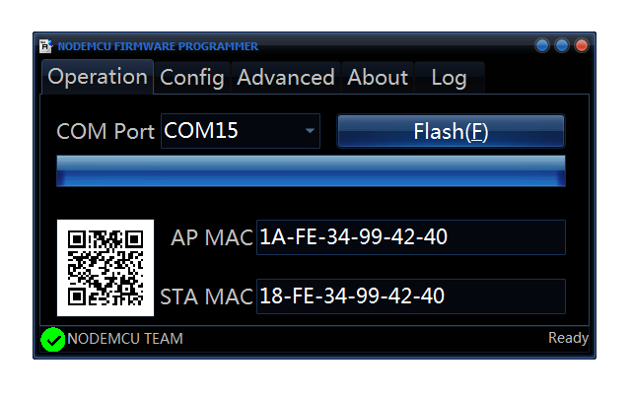

1. Click config tab

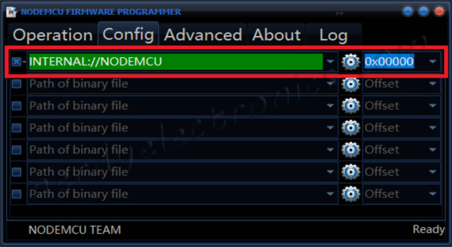

1. Click the gear icon and select the file “LinkShades-Hardwired.ino.nodemcu.bin”.
2. Click Operation tab.
3. Plug in NodeMCU. The port should auto detect.
4. Click Flash, this will take about 1 minute. The LED on the board will flash quickly while uploading.
5. The LED on the board should start blinking more slowly when complete.